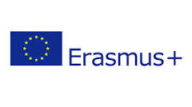
ERASMUS+ PROGRAMM FOR TEACHING EXCHANGE (STA) 2022/2023
LETTER OF INVITATION
UNIVERSITY OF __________________________________________________
ERASMUS code: ___________________________________________________
I confirm that our University is willing to host the teacher Mr./Ms. _____________________________________________from the UNIVERSITY OF CORDOVA (Spain) for a teaching exchange within the framework of the Erasmus Teaching Staff Mobility Programme (STA), in the academic year 2022/2023 to provide teaching of a minimum of 8 hours in the field of _____________________________________ in_______________language.
Degree

Joint Degree

Master

Doctorate
I hereby declare that our University has signed a bilateral agreement with the University of Cordova for the above-mentioned academic year including teaching staff mobility. The overall costs for this STA Erasmus+ exchange will be covered by the home university.
I also confirm that I am entitled to issue this declaration.
Erasmus coordinator
Date and stamp of the institution

